**AMETRYN**

**133**

# 

*ISO Common Name* Ametryn

*Chemical Name* 4-N-ethyl-6-methylsulfanyl-2-N-propan-2-yl-1,3,5-triazine-diamine

*Empirical Formula* C9H17N5S

*RMM* 227.33

b.p. about 248°C (decomposition)

*CAS Number*: 834-12-8

**AMETRYN TECHNICAL**

**\*133/TC/M/-**

# Sampling Take at least 250 g.

# Identity Tests

## 2.1 Infrared. Prepare a film between sodium chloride plates and scan from 4000 to 600 cm-1. The spectrum obtained from the sample should not differ significantly from that of the reference grade material.

## 2.2 GLC. Use the GLC method below. The relative retention time of Ametryn with respect to the internal standard for the sample solution should not deviate by more than 2% from that of the calibration solution.

## 3 AMETRYN

OUTLINE OF METHOD

The sample of Ametryn technical material is dissolved in Acetone, containing an internal standard, and the Ametryn content (g/kg) is determined by capillary gas chromatography with flame ionization detection.

REAGENTS

*Ametryn* reference standard, of known purity

*Acetone* Chromatographic grade

*Dipropyl phthalate* Internal Standard. Must not contain impurities with the same retention time as Ametryn.

*Internal Standard Solution.* Prepare a single stock of 3.0 mg/ml internal standard solution, of sufficient volume for all samples to be analyzed. For example, to prepare 1000 ml stock solution, dissolve 3.0 g of Dipropyl phthalate in 1000 ml acetone.

* Provisional CIPAC method 2020. Based on a method supplied by Syngenta Crop Protection, USA

*Calibration Solution*. Prepare calibration solutions in duplicate (CA and CB). Weigh (to the nearest 0.1 mg) 140 – 160 mg (*s* mg) of reference standard into a suitable glass container (for example, a glass bottle with 50 ml capacity). Add by pipette or calibrated dispenser 25.0 ml of internal standard stock solution. Place the capped glass container for 10 minutes in an ultrasonic apparatus. Mix thoroughly and transfer a portion of solution into chromatographic injection vials by filtering with a 0.45 µm filter.

APPARATUS

*Gas chromatograph* equipped with a split/splitless injection and a flame ionization detector.

*Capillary column* fused silica, 30 m x 0.25 mm (i.d.), film thickness: 0.25 µm, coated with crosslinked polyethylene glycol (DB-WAX or equivalent).

*Ultrasonic bath*

*Electronic integrator or data system*

*Sample filtering device* with a membrane filtration unit compatible with organic solvents and a 0.45 µm pore diameter (for example, PTFE)

PROCEDURE

*(a) Gas Chromatographic conditions* (typical)

|  |  |
| --- | --- |
| *Column*  *Injection system*  Injector  Injection volume  Split ratio  *Detector* | fused silica, 30 m x 0.25 mm (i.d.), 0.25 µm film  coated with crosslinked polyethylene glycol (DB-WAX or equivalent).  split injection  1 µl  40:1  flame ionization |
| Temperatures  Injection port  Detector  Oven | 275°C  300°C  200°C ( ±10°C) isothermal |
| *Gas flow rates*  *Column* |
|  |
| Helium (carrier) | 2.5 ml/min, run at constant flow |
| *Detector* |
| Air  Hydrogen | 350 ml/min  35 ml/min |
| *Retention times* |
| Ametryn  Internal standard | 17 min (approximate)  5 min (approximate) |
|  |  |

*(b) System equilibration.* Prepare two calibration solutions. Inject 1 µl portions of solution CA until the response factors *(fi)* obtained for two consecutive injections differ by less than 1.0%. Then inject a 1 µl portion of the solution CB. The response factor, *fi*, for this solution should not deviate by more than 1.0% from that of solution CA, otherwise prepare new calibration solutions. If the peak retention times differ significantly from the approximate values quoted, then the flow rate (pressure) of the carrier gas may be adjusted accordingly.

*(c) Sample preparation.* Prepare solutions in duplicate for each sample. Weigh (to the nearest 0.1 mg) sufficient sample to contain 140 - 160 mg (*w* mg) of Ametryn into a suitable glass container (for example, a glass bottle with 50 ml capacity). Add by pipette or calibrated dispenser 25.0 ml of the internal standard stock solution. Place the capped glass container for 10 minutes in an ultrasonic apparatus. Mix thoroughly and filter solutions through a 0.45 µm filter prior to analysis (solutions SA and SB).

*(d) Determination.* If not otherwise requested inject in duplicate 1 µl portions of each sample solution bracketing them with duplicate injections of the calibration solution as follows: calibration solution CA, calibration solution CB, calibration solution CA, sample solution S1A, sample solution S1B, calibration solution CA, sample solution S2A, sample solution S2B, calibration solution CA, and so on for further samples. Measure the relevant peak areas. If the peak shapes and precision of analysis deteriorate, this may indicate the build-up of formulation residue in the GC instrument, necessitating maintenance of injection ports. Consider replacing injection liners, gold seals and/or split vent lines.

*(e) Calculation.* Calculate the mean value of each pair of calibration response factors, bracketing the two injections of a sample, and use this value for calculating the Ametryn contents of the bracketed sample injections.

*fi* = *Ir* **×** *s* **×** *P*

*Hs*

Content of Ametryn in sample (g/kg) = *f* **×** *Hw*

*Iq***×**  *w*

where:

*fi* = individual response factor  
*f* = mean response factor   
*Hs* = Peak area of Ametryn in the calibration solution  
*Hw* = Peak area of Ametryn in the sample solution

*Ir* = Peak area of the internal standard in the calibration solution

*Iq* = Peak area of the internal standard in the sample solutions

*s* = mass of Ametryn reference standard in the calibration solution (mg)

*w* = mass of sample taken (mg)

*P* = Purity of Ametryn reference standard (g/kg)

**Repeatability r** = 10 to 13 g/kg at an active ingredient content of 968 to 972 g/kg

**Reproducibility R =** 19 to 20 g/kg at an active ingredient content of 968 to 972 g/kg

**AMETRYN WATER DISPERSIBLE GRANULES**

**\*133/WG/M/-**

# Sampling. Take at least 250 g. Mix thoroughly to obtain sample homogeneity.

# Identity Tests

## Infrared As for technical 133/TC/M/2.1 and Fig 1.

## GLC As for technical 133/TC/M/2.2 and Fig 3.

# AMETRYN

As for Ametryn technical 133/TC/M/3.

APPARATUS

As for Ametryn technical 133/TC/M/3.

PROCEDURE

*(c) Sample preparation.* Prepare solutions in duplicate for each sample. Homogenize the test sample thoroughly. Weigh (to the nearest 0.1 mg) sufficient sample to contain 140 - 160 mg (*w* mg) of Ametryn (equal to approximately 175 – 200 mg WG formulation containing 800 g/kg Ametryn) into a suitable glass container (for example, a glass bottle with 50 ml capacity). Add by pipette or calibrated dispenser 25.0 ml of the internal standard stock solution to the weighed aliquot. Place the capped glass container for 10 minutes in an ultrasonic apparatus. Mix thoroughly and filter solutions through a 0.45 µm filter prior to analysis (solutions SA and SB).

**Repeatability r** = 14 g/kg at an active ingredient content of 795 g/kg

**Reproducibility R =** 34 g/kg at an active ingredient content of 795 g/kg

* Provisional CIPAC method 2020. Based on a method supplied by Syngenta Crop Protection, USA

**AMETRYN SUSPENSION CONCENTRATES**

**\*133/SC/M/-**

# Sampling. Take at least 250 ml. Mix thoroughly to obtain sample homogeneity.

# Identity Tests

## Infrared As for technical 133/TC/M/2.1 and Fig 1.

## 2.2 GLC As for technical 133/TC/M/2.2 and Fig 4.

# AMETRYN

As for Ametryn technical 133/TC/M/3.

APPARATUS

As for Ametryn technical 133/TC/M/3.

PROCEDURE

*(c) Sample preparation.* Prepare solutions in duplicate for each sample. Homogenize the test sample thoroughly. Weigh (to the nearest 0.1 mg) sufficient sample to contain 140 - 160 mg (*w* mg) of Ametryn (equal to approximately 310 – 350 mg SC formulation containing 457 g/kg Ametryn) into a suitable glass container (for example, a glass bottle with 50 ml capacity). Add by pipette or calibrated dispenser 25.0 ml of the internal standard stock solution to the weighed aliquot. Place the capped glass container for 10 minutes in an ultrasonic apparatus. Mix thoroughly and filter solutions through a 0.45 µm filter prior to analysis (solutions SA and SB).

**Repeatability r** = 7.7 to 10 g/kg at an active ingredient content of

435 to 447 g/kg

**Reproducibility R =** 19 to 20 g/kg at an active ingredient content of

435 to 447 g/kg

* Provisional CIPAC method 2020. Based on a method supplied by Syngenta Crop Protection, USA



# Fig 1 Typical IR spectrum according to 133/TC/M/2.1

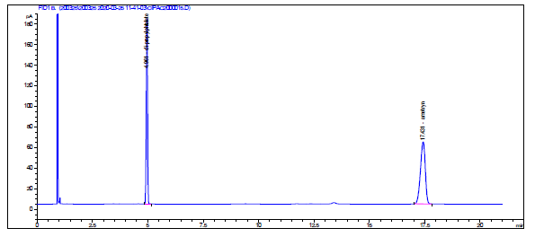

**Fig 2** Typical chromatogram of Ametryn TC

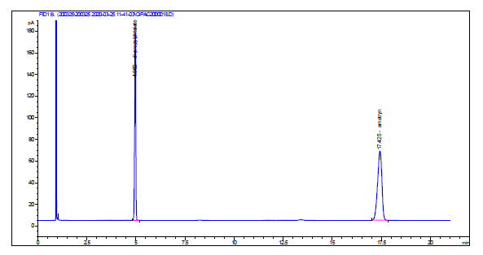

**Fig 3** Typical chromatogram of Ametryn in WG Formulation

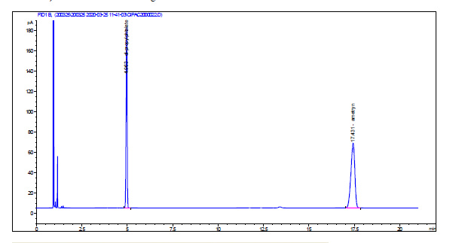

**Fig 4** Typical chromatogram of Ametryn in SC Formulation